**Name: Minh Huy Do – Intern at WIMMICS/INRIA SOPHIA ANTIPOLIS**

**RDF Lab**

**1. first.ttl**

Margot is a 32 years old woman, her shoe size is 38 and her pants size is 40. She is married to Arthur, with whom she has two children: Simon and Marie. Margot is a teacher; Alice and Pierre are her colleagues. Her mother is called Simone.

1. Formalize the above natural language statements in RDF, in the Turtle syntax.

2. Validate your Turle data with an online validator.

3. Save your Turtle data in a file first.ttl.

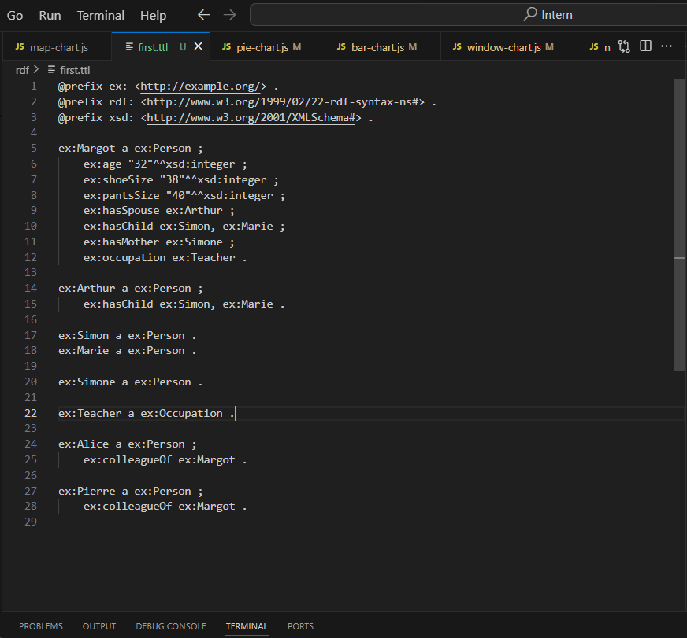

4. Translate your Turtle data in the XML syntax.

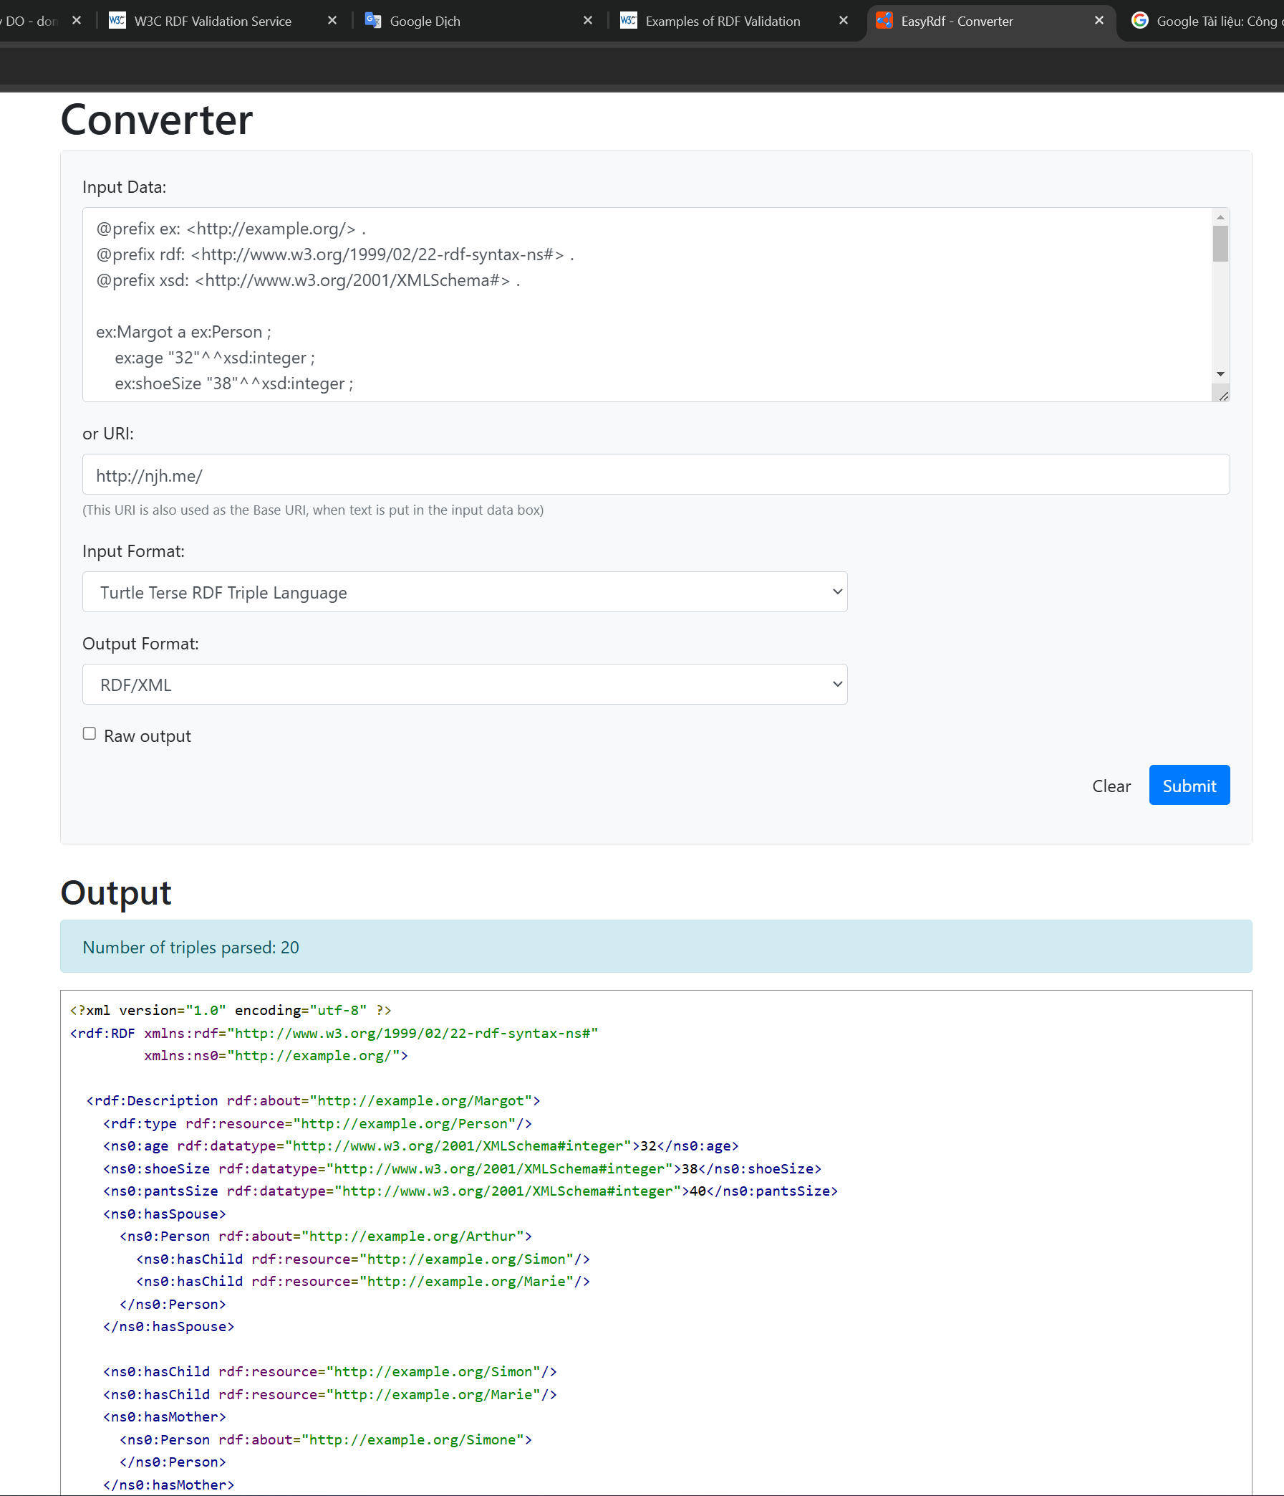

5. Save your RDF/XML data in a file first.rdf and validate them with the W3C validation service.

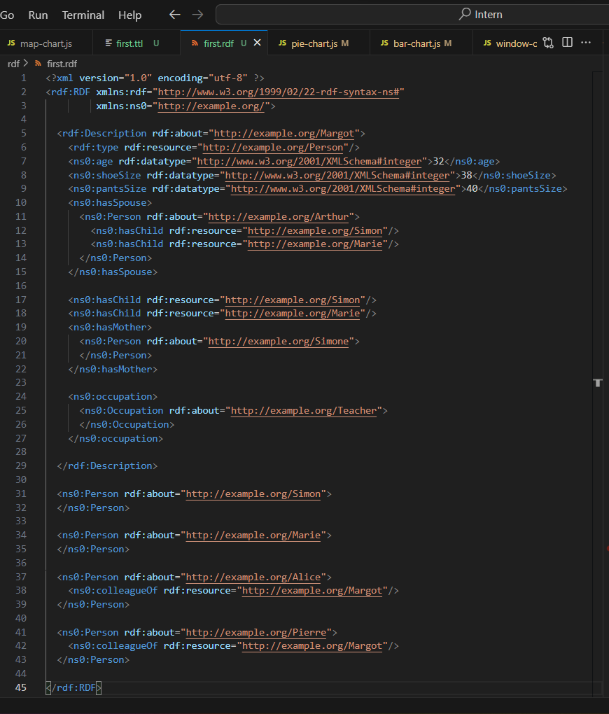

6. Download and launch the Corese standalone interface. It proposes two tabs: (1) to download input files and visualize execution traces, and (2) to edit or to load SPARQL queries and visualize the result of their execution on the loaded RDF files. A default SPARQL query is available : select ?x ?t where {?x rdf:type ?t}

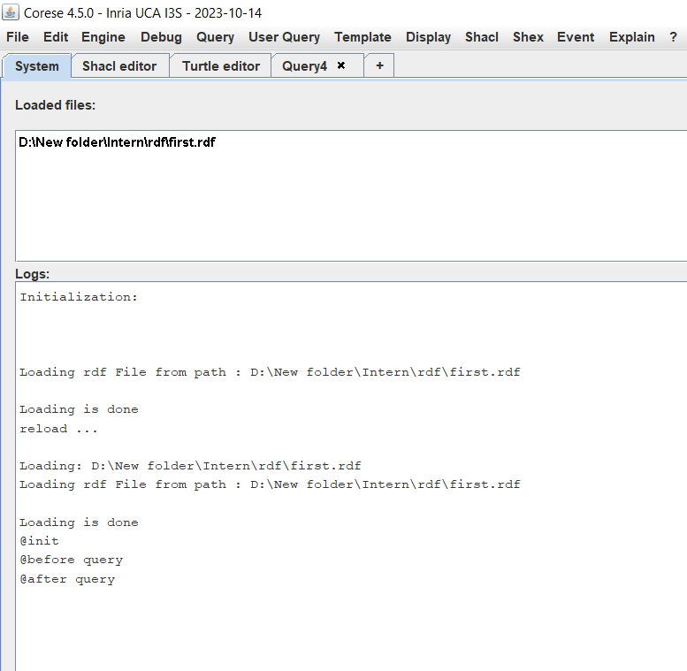

7. The SPARQL language will be presented in a next course. Today, you just need to understand that this query enables to retrieve all the resources referred to in the loaded RDF dataset and their types. Execute the query and examine the result.

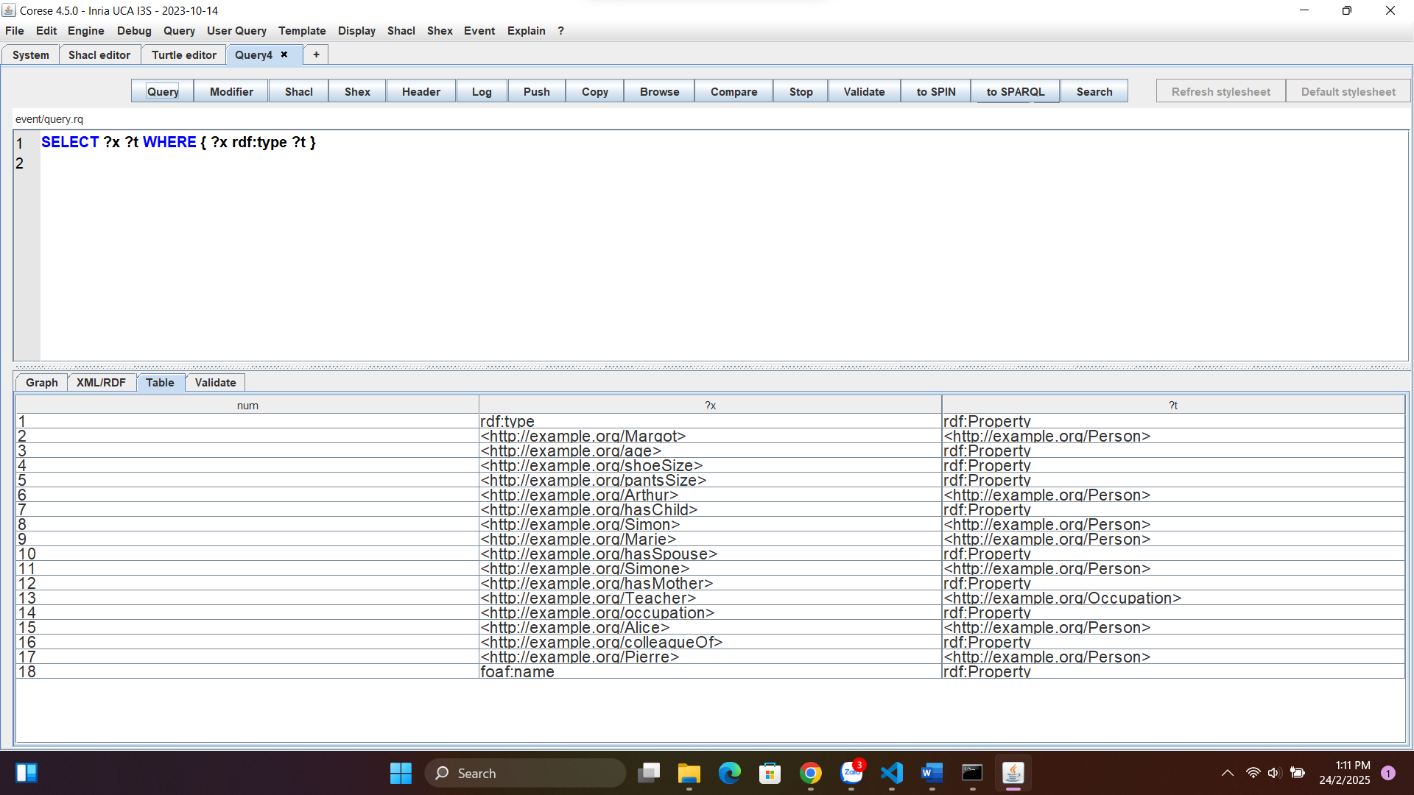

**2. human.ttl**

Examine the RDF graph available at http://ns.inria.fr/humans/humans_data.html. Download its Turtle serialization at http://ns.inria.fr/humans/humans_data.ttl and examine it.

1. What is the namespace used for the instances/resources created in this file? Which mechanism enables to associate the instances and the namespace ?

- The name space: @prefix ex: <http://ns.inria.fr/humans#> .

- Mechanism Enables: @prefix

Ex: <http://ns.inria.fr/humans#John> a <http://ns.inria.fr/humans#Person> . = ex: John a ex:Person.

2. What is the namespace of the RDF schema used in this file and how is it associated to the properties and classes?

- Namespace of RDF schema:

+ @prefix rdfs: <http://www.w3.org/2000/01/rdf-schema#> .

+ @prefix owl: <http://www.w3.org/2002/07/owl#> .

- Associate to the classes: Use rdfs: Class - ex:Person a rdfs:Class .

- Associate to the properties: Use rdfs: Property - ex:hasFriend a rdf:Property ; rdfs:domain ex:Person ; rdfs:range ex:Person .

3. Find all the information available on John in this file.

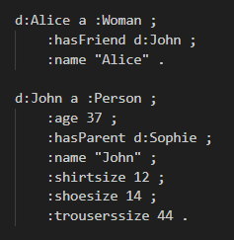

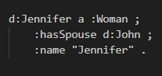

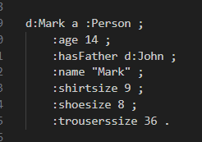

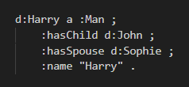

**3. second.ttl**

Tim Berners-Lee is the inventor of the Web, graduated from Queen's College in Oxford in UK, and is a professor at MIT in Cambridge in the USA. He received the Turing Award awarded by the Association for Computing Machinery (ACM) in USA in 2016 and the Queen Elizabeth Prize in 2013 awarded by the Queen of UK.

Follow the same steps as for first.ttl

1. Formalize the statements in RDF using Turtle

2. Validate the Turtle data with an online validator

3. Save the data in a file second.ttl

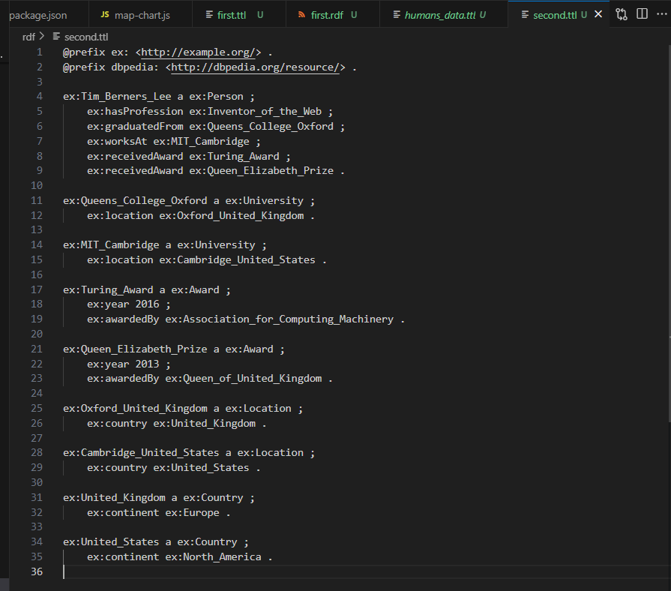

4. Translate the Turtle data to RDF/XML syntax

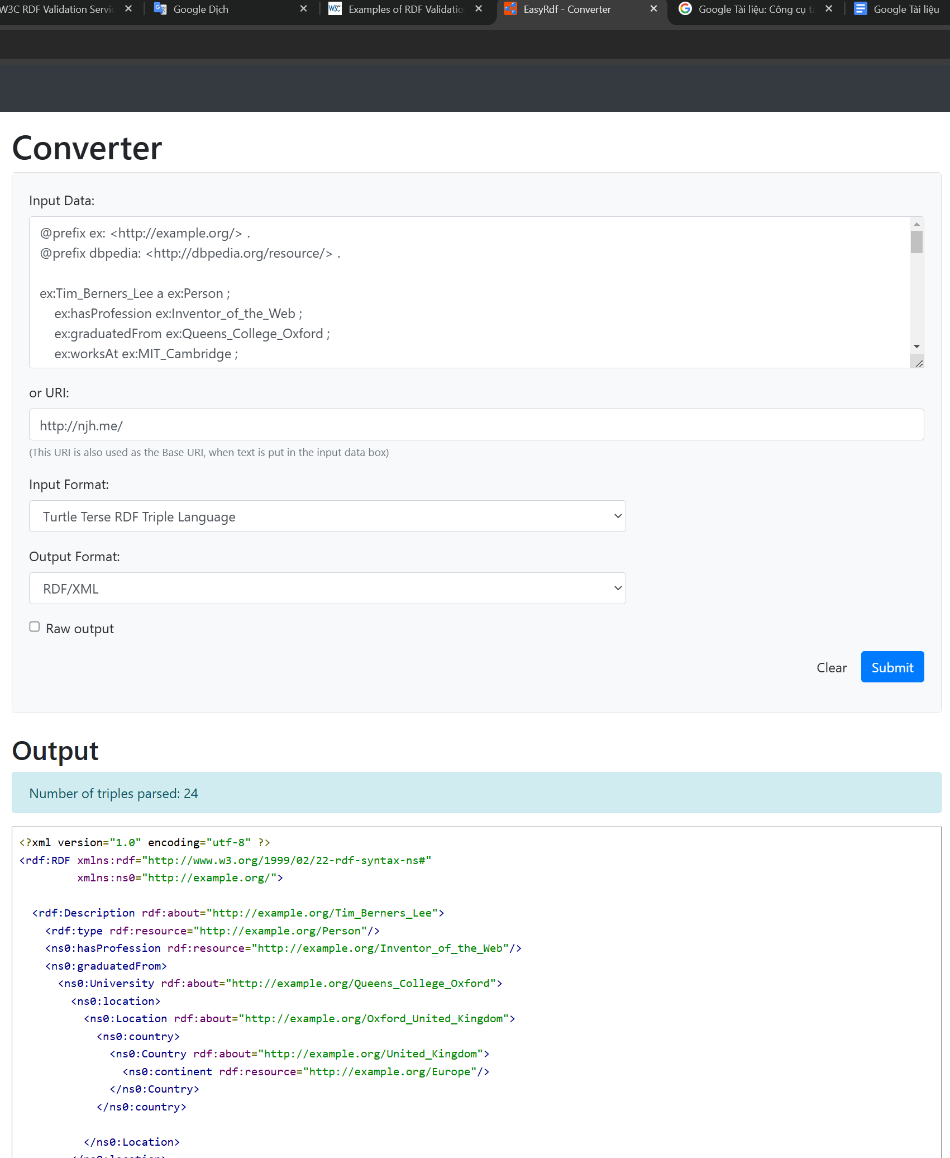

5. Save RDF/XML data in second.rdf file

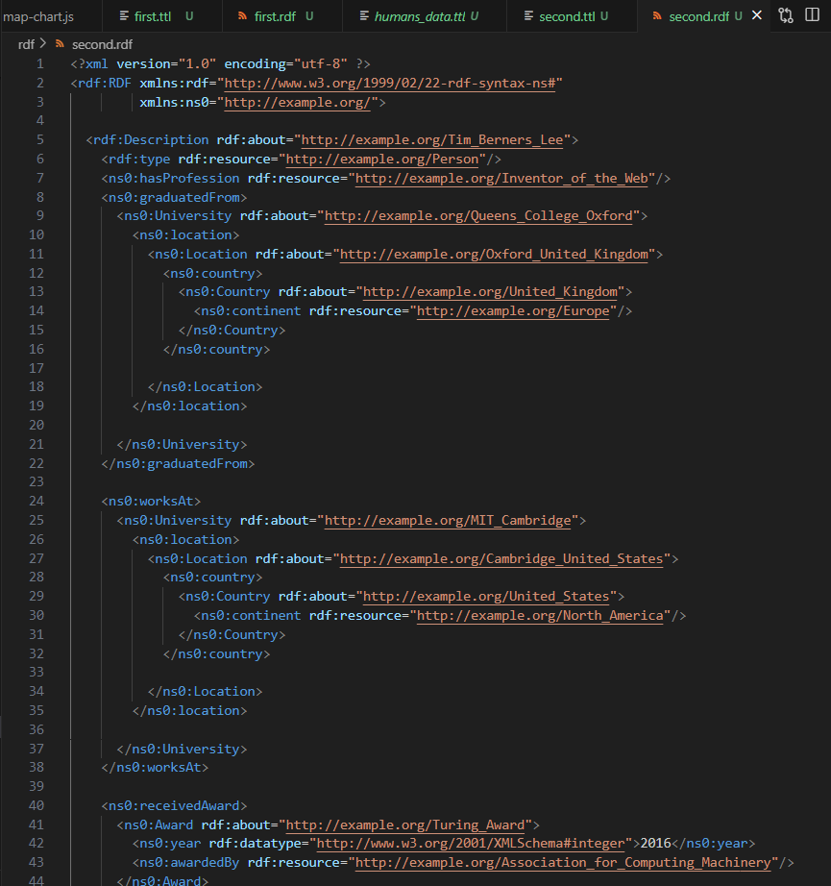

6. Download and launch the Corese standalone interface. It proposes two tabs: (1) to download input files and visualize execution traces, and (2) to edit or to load SPARQL queries and visualize the result of their execution on the loaded RDF files. A default SPARQL query is available : select ?x ?t where {?x rdf:type ?t}

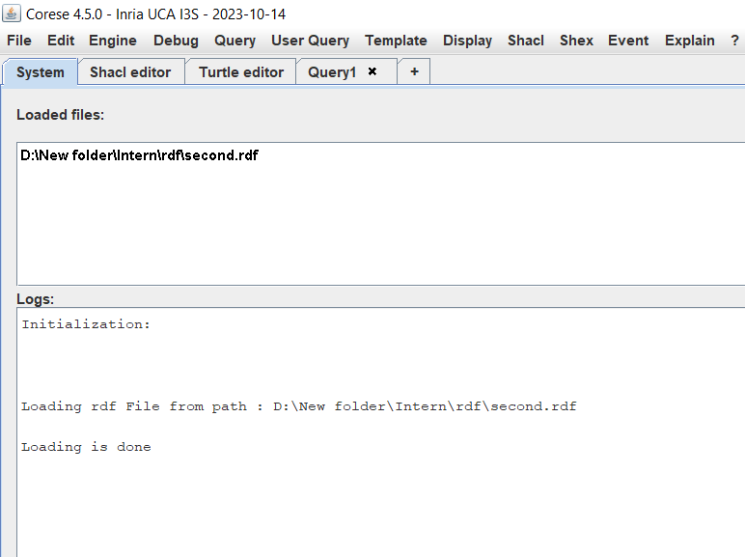

7. The SPARQL language will be presented in a next course. Today, you just need to understand that this query enables to retrieve all the resources referred to in the loaded RDF dataset and their types. Execute the query and examine the result.

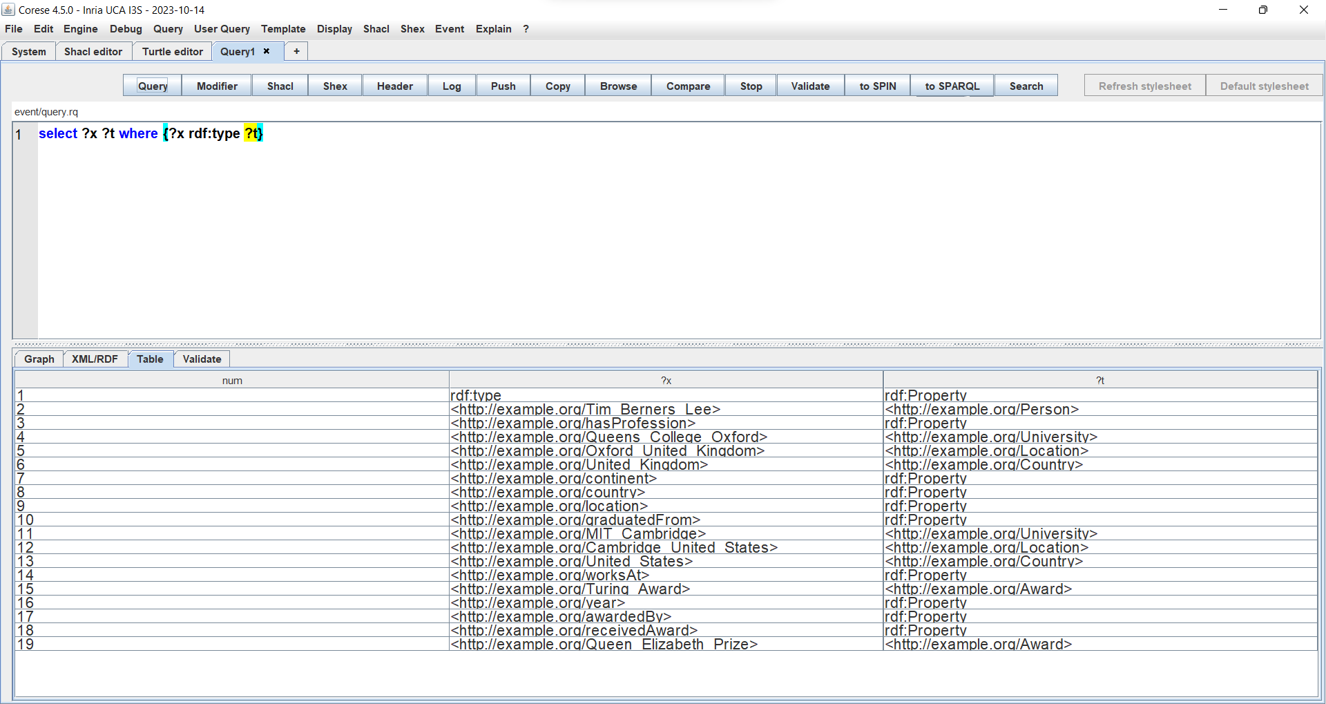

**4. third.ttl**

Process P23 consists of task T122, followed by task T153, followed by subprocess P175, in this order; and P175 consists of task T19 followed by task T47. Alice Duncan is an agent of all the tasks in P23; she manages John Tiwac who is an agent of tasks T122 and T153; the software agent HAL9000 participates to tasks T122 and T19

Follow the same steps as for first.ttl

1. Formalize the above natural language statements in RDF, in the Turtle syntax.

2. Validate your Turle data with an online validator.

3. Save your Turtle data in a file first.ttl.

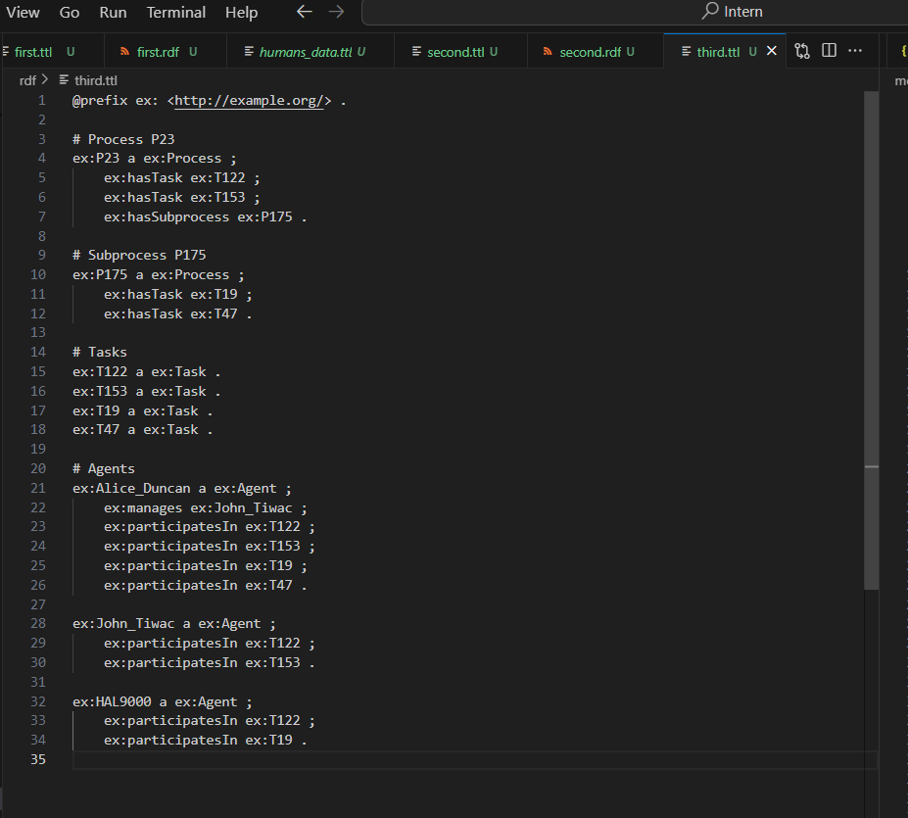

4. Translate your Turtle data in the XML syntax.

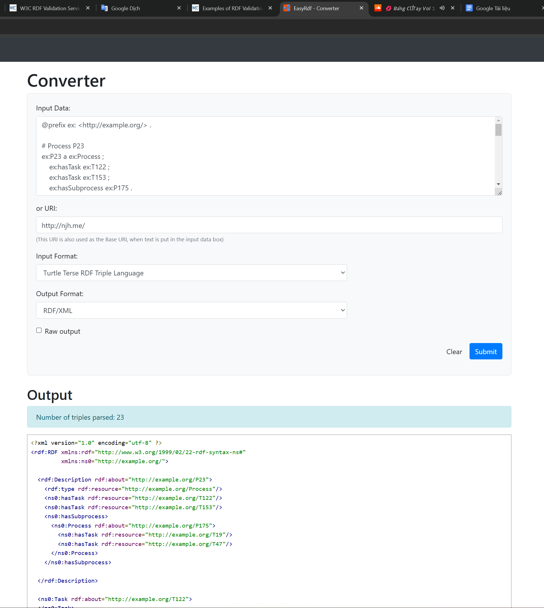

5. Save your RDF/XML data in a file first.rdf and validate them with the W3C validation service.

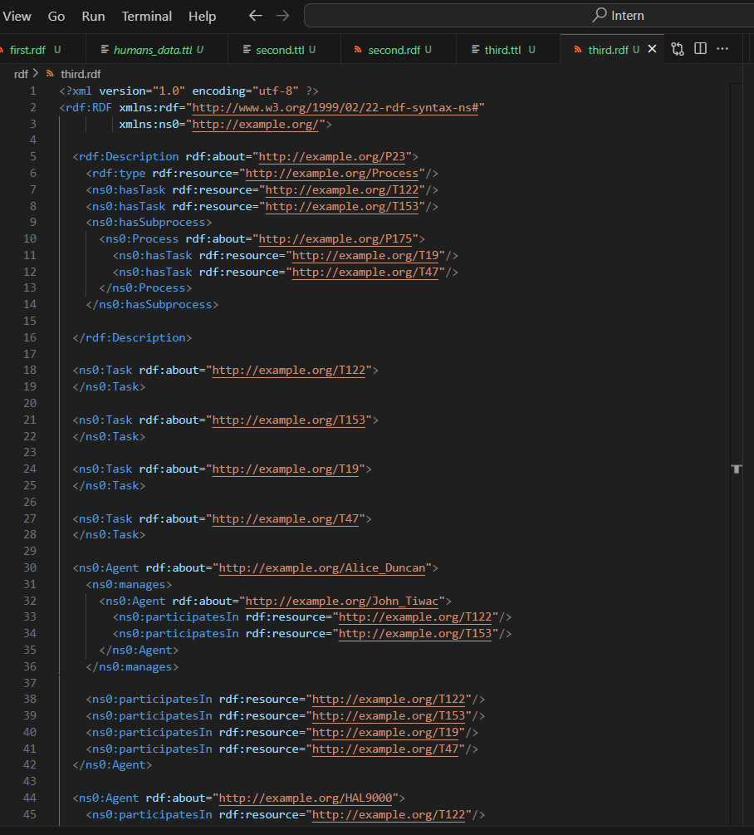

6. Download and launch the Corese standalone interface. It proposes two tabs: (1) to download input files and visualize execution traces, and (2) to edit or to load SPARQL queries and visualize the result of their execution on the loaded RDF files. A default SPARQL query is available : select ?x ?t where {?x rdf:type ?t}

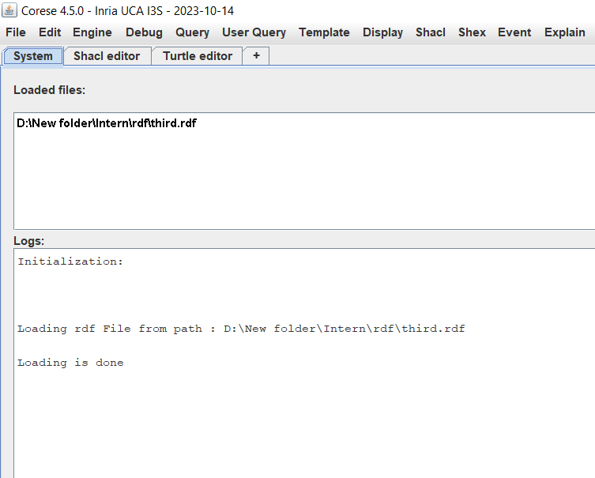

7. The SPARQL language will be presented in a next course. Today, you just need to understand that this query enables to retrieve all the resources referred to in the loaded RDF dataset and their types. Execute the query and examine the result.

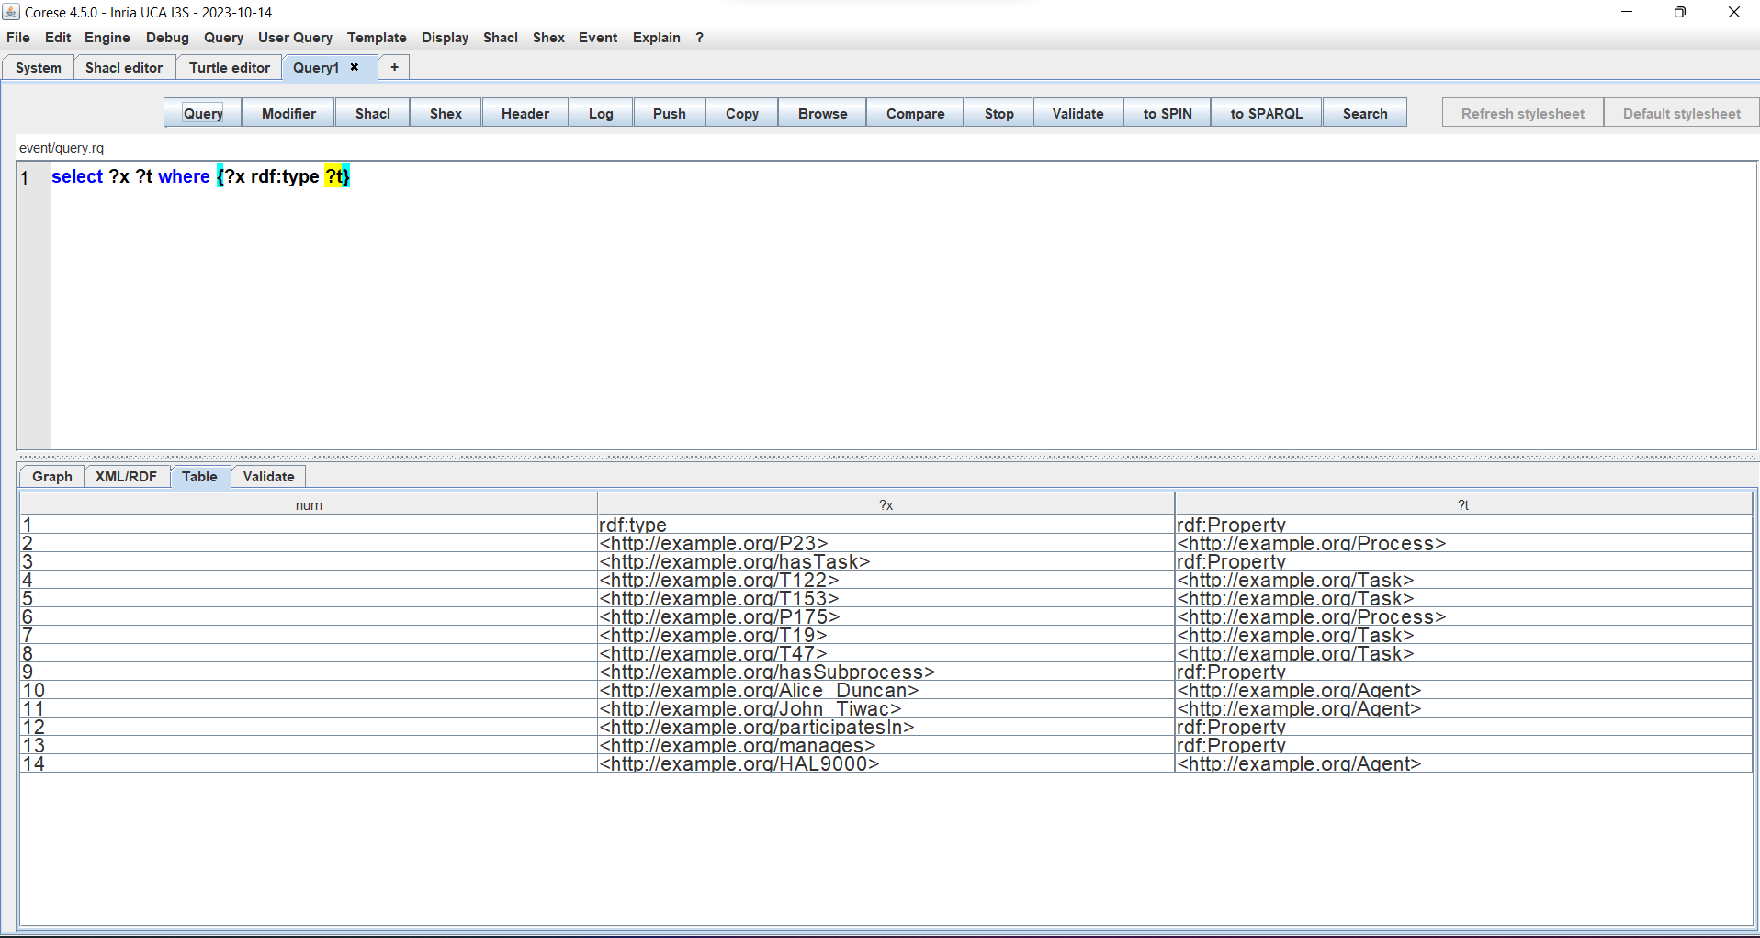

**5. DBpedia**

Get the RDF data about Paris on DBpedia.org, find the triple expressing that it is a capital in Europe.

